Novel Cookware Pvt. Ltd.

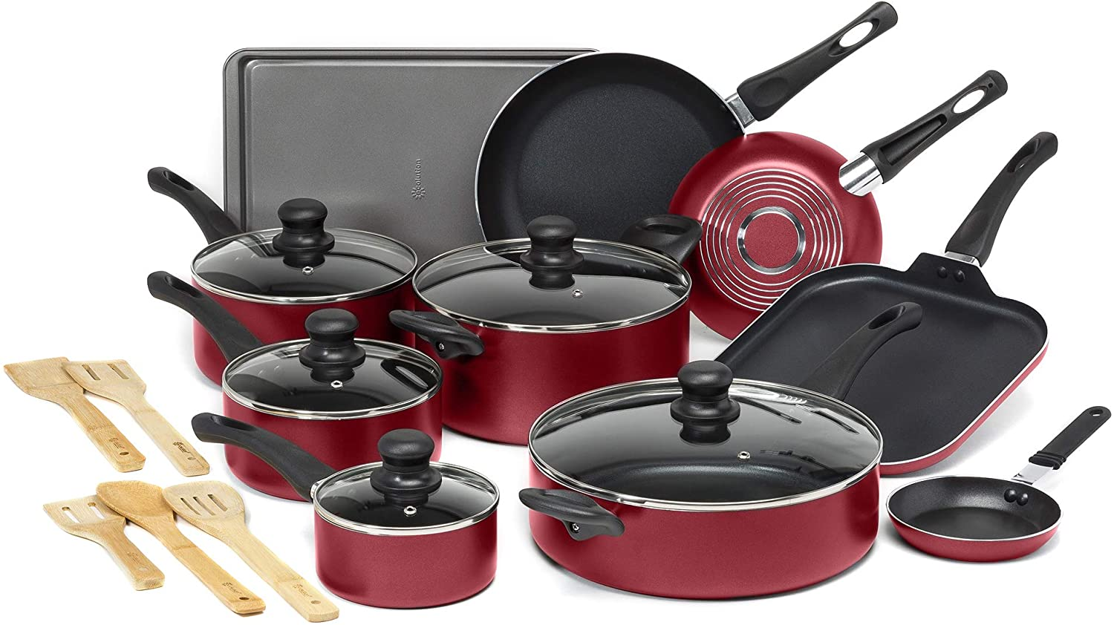

* Name: - Harshal Sanas
* Grade: - XII – F, Science
* Roll No.: - 28
* Academic Year: - 2021-22
* School Name: - Poddar Brio International School

CERTIFICATE

CLASS: XII-F YEAR: 2021-2022

This is to certify that project on Novel Cookware Pvt. Ltd. is successfully completed by **Harshal Sanas** of Class: XII-F, from 2021-22 batch.

This project was solely completed and coded by

**Harshal Sanas**.

Head Teacher External Internal

Examiner Examiner

(Subject Teacher)

Signature:

Date: / / 22 Department of: COMPUTER SCI.

Principal

Acknowledgement:

*I, Harshal Sanas of class XIIth-F would like to express my sincere gratitude to my computer science teacher*

*Mrs. Pooja, PGT COMPUTER SCIENCE, for her vital support, guidance and encouragement – without which this project would not have come forth.*

*I would also like to express my gratitude to my school Poddar Brio International School for letting me use the school laboratory.*

**Index**

|  |  |  |
| --- | --- | --- |
| Sr.No. | Topic | Remark |
| 1. | Objective of the project |  |
| 2. | Need for computerisation |  |
| 3. | Software and Hardware requirements |  |
| 4. | Advantages |  |
| 5. | Limitations |  |
| 6. | Source code |  |
| 7. | Output Screenshots |  |
| 8. | Future enhancement of the project |  |
| 9. | Bibliography |  |

**Objective of the Project**

The main purpose of creating a python project on sport shop management is aid the complexities existing in managing the shop with variety of goods available in large amounts, availability of stocks, etc., efficiently with the help of knowledge of computer science.

The project is totally built at administrative end and only administrator is guaranteed the access.

The purpose of the project is to build an application program to reduce the manual work for managing the sales, discounts, stock, and payments.

It tracks all the details about stocks, products, and inventory; it also prints various reports as per input given by the user.

**INPUT DATA AND VALIDATION**

**OF PROJECT**

1. All the fields such as sales payments discounts are validated and does not take invalid values.
2. Each form of sales, discounts, stock cannot accept the blank values.
3. Avoiding errors in data.
4. Controlling amount of input.

**SOFTWARE AND HARDWARE REQUIREMENTS**

**Data file handling** has been effectively used in the program. The database is a collection of interrelated data to serve multiple applications. That is database programs create files of information. So we see that files are worked with most, inside the program.

**DBMS: -** The software required for the management of data is called as DBMS. It has3 models:

• Relation model

• Hierarchical model

• Network model

**RELATIONAL MODEL: -**It’s based on the concept on relation. Relation is the table that consists of rows and columns. The rows of the table are called tuple and the columns of the table are called attribute. Numbers of rows in the table is called as cardinality. Number of columns in the table is called as degree.

**HIERARCHICAL MODEL: -** In this type of model, we have multiple records for each record. A particular record has one parent record. No chide record can exist without parent record. In this, the records are organized in tree.

**NETWORK MODEL: -**In this, the data is represented by collection of records and relationship is represented by (ink or association).

**CHARACTERISTICS OF DBMS: -**

• It reduces the redundancy

• Reduction of data in inconsistency

• Data sharing

• Data standardization

**DIFFERENT TYPES OF FILES: -BASED ON ACCESS**: -

• Sequential file

• Serial file

• Random (direct access) file BASED ON STORAGE

• Text file

• Binary File

**NEED OF COMPUTERISATION**

The trading then and now continues to be the part of mainstream of economy of any country whether being retail or wholesale. However, in this modern era with increase in demand in the market for variety of products and thereby to sustain in this competitive market it has been hectic to manage the complexities arousing in manging inventory of the shops. However, with advent of Computer Science, the technology can be harnessed to overcome this issue of managing modern day businesses very efficiently. It also helps to manage the employees.

With the market evolving as function of time so are threats. However, computerisation has the solution to this problem. It protects the businesses from any break ins and any cyber-attack as it grants access to only persons who have authentication credentials required to have access to your data thereby acting as protective layer for any businesses from cyber-attacks.

**Advantages**

1. Reduce costs by automating routine tasks, such as record-keeping, accounting and payroll
2. Improve customer service or supplier relationships
3. Develop more effective communication within the business or with customers
4. Increase business efficiency and staff productivity
5. Increase employee morale
6. Expand your business offer or reach new markets - eg through an online shop
7. Develop a competitive advantage by implementing the right business technology.

**Limitations**

1. **Personal use of Computers:** - Computers can create distractions, especially if employees are provided with full Internet access.
2. Dangers of Hacking
3. Invasion of Privacy
4. Heavy Reliance on Data

**Source Code**

**A. SQL Screenshots**

1.Product Table

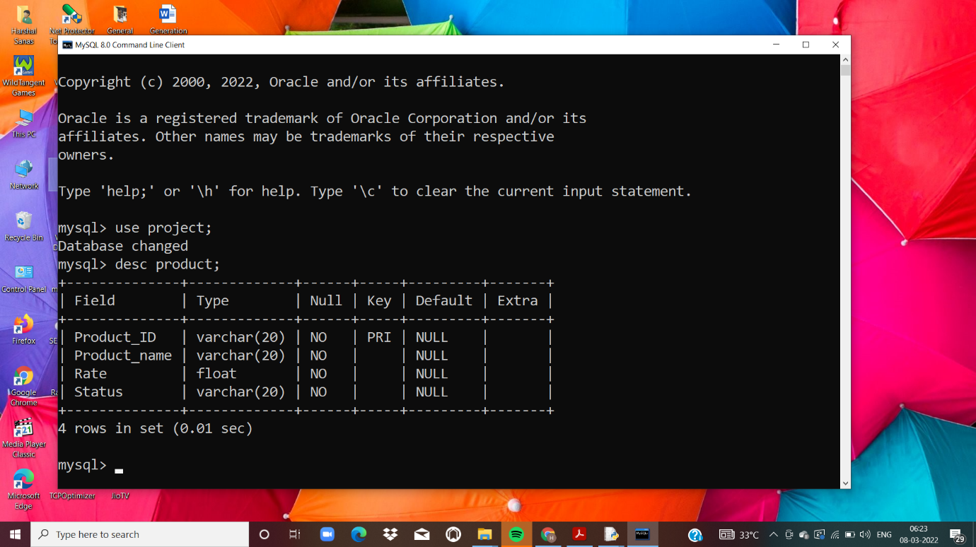

2.Purchase Table

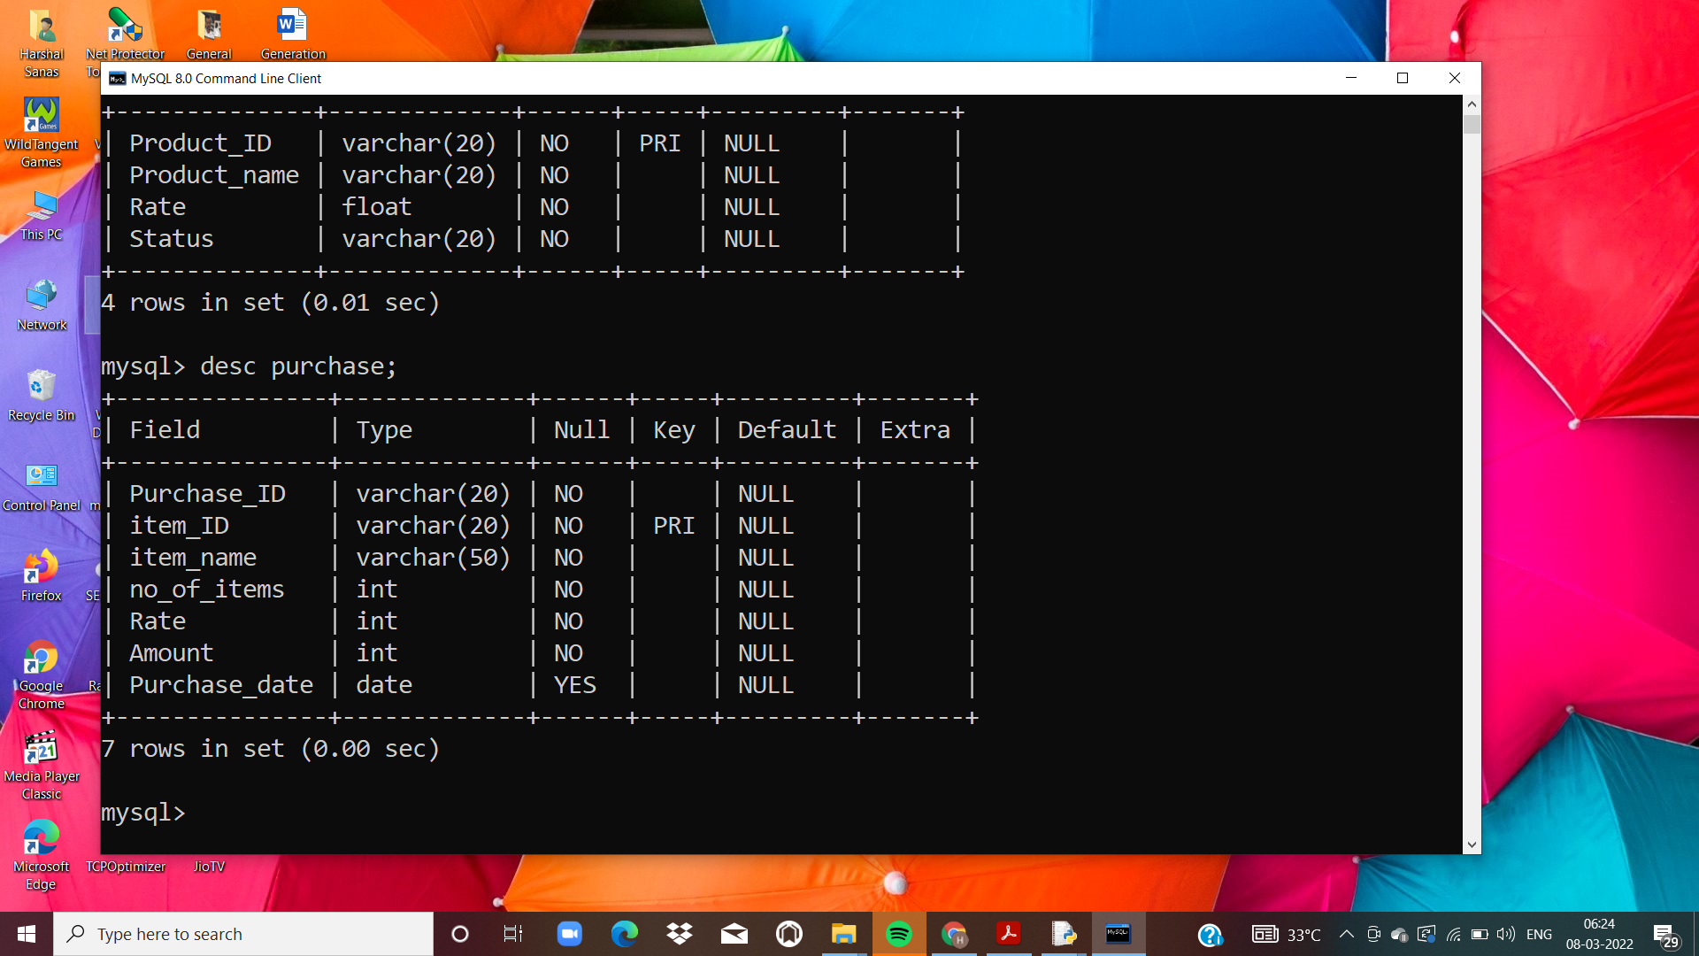

3.Processing Table

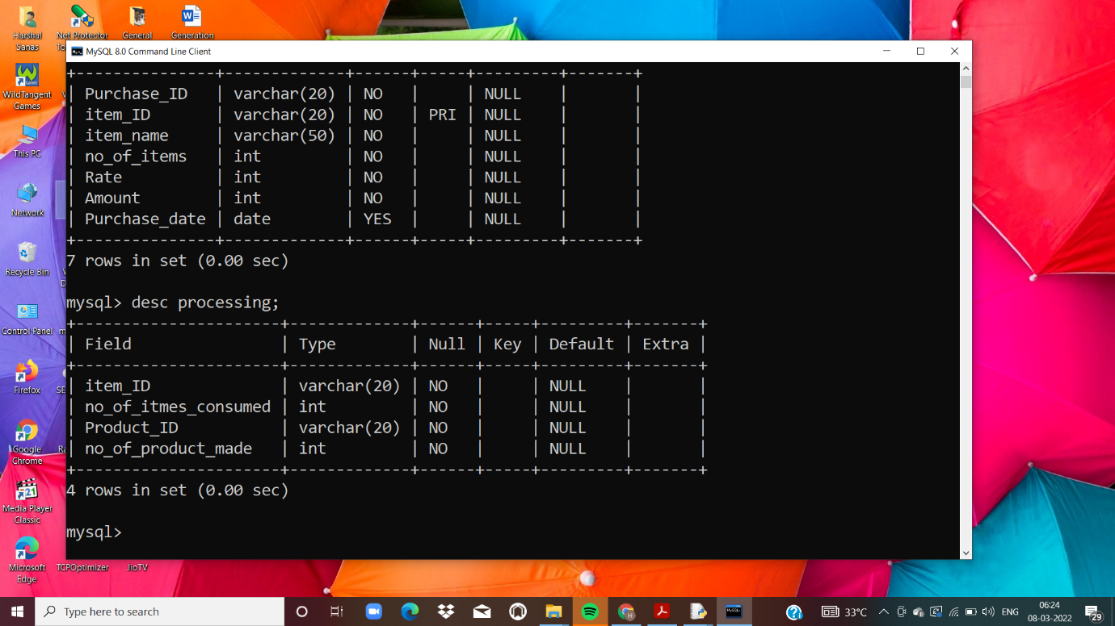

4. Sale Table

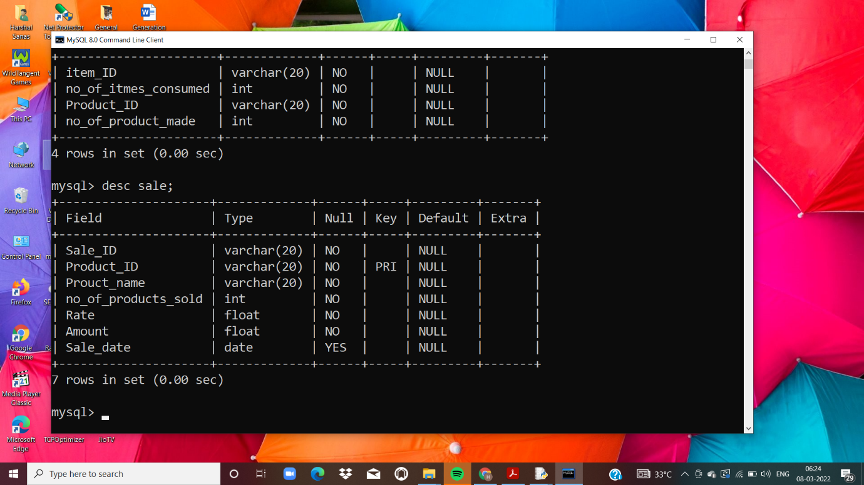

5. Stock Table

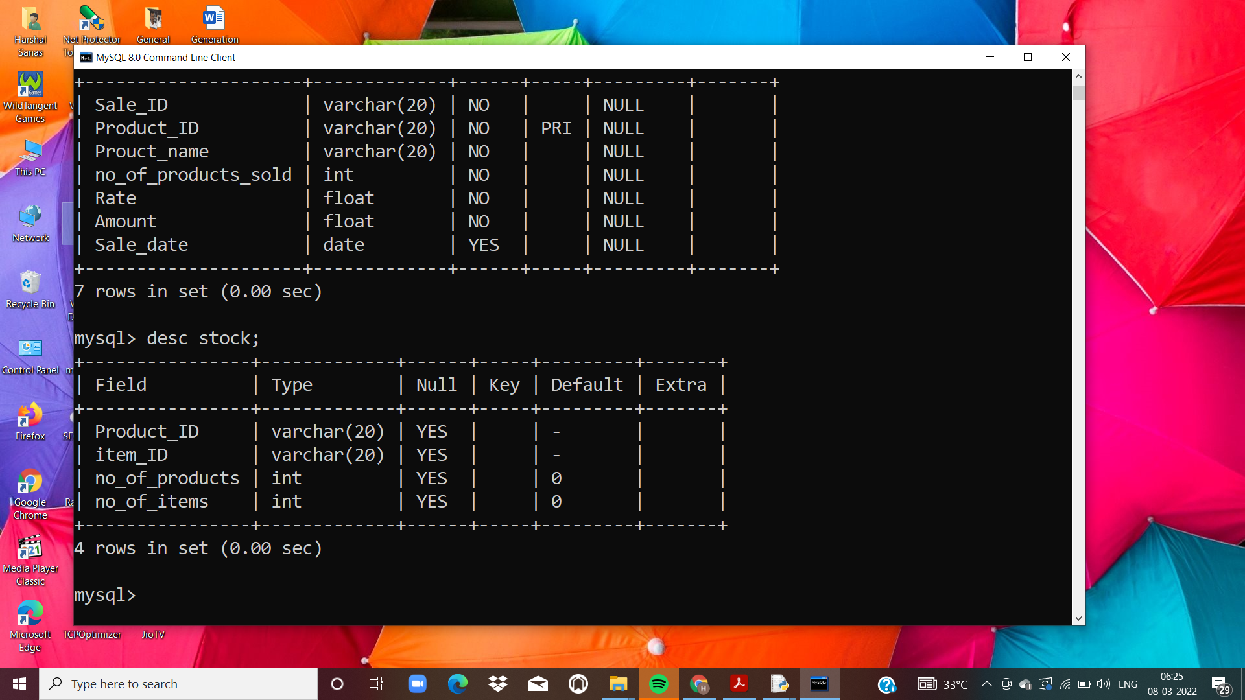

**B. Python SQL interface (Source Code)**

import mysql.connector

db=mysql.connector.connect(

host='localhost',

user='root',

password='admin',

database='project')

if db.is_connected()==False:

print('connetion not established')

elif db.is_connected()==True:

print('connection established')

mycursor=db.cursor()

def View_Product():

c='y'

while c.lower()=='y':

mycursor.execute('select * from product')

data=mycursor.fetchall()

if data==[]:

print('no data in this table ')

else:

for row in data:

print(row)

c=input("Do u want to continue, press 'y' to continue or any other key to exit ")

def Add_Product():

c='y'

while c.lower()=='y':

Product_ID=input('Enter the id of the product: ' )

Product_name=input('Enter the name of the product: ' )

Rate=float(input('Enter the rate of the product: ' ))

Status=input('Enter the status of the product:- Availabele or Unavailable ')

ins="insert into product(Product_ID,Product_name,Rate,Status) values('{}','{}',{},'{}')".format(Product_ID,Product_name,Rate,Status)

mycursor.execute(ins)

db.commit()

print('Data corresponding to',Product_name,'with Product_ID',Product_ID,'is added')

c=input("Do u want to continue, press 'y' to continue or any other key to exit ")

def Update_Product():

c='y'

while c.lower()=='y':

pid=input('Enter the Product_ID of the product to be updated: ')

feild=input('Enter the field to be updated: ')

new_value=input('Enter the new value to be updated: ')

update="update product set {}='{}' where Product_ID=('{}')".format(feild,new_value,pid)

mycursor.execute(update)

db.commit()

print(feild,'of',pid,'is updated to',new_value)

c=input("Do u want to continue, press 'y' to continue or any other key to exit ")

def View_Purchase():

c='y'

while c.lower()=='y':

mycursor.execute('select * from purchase')

data=mycursor.fetchall()

if data==[]:

print('no data in this table ')

else:

for row in data:

print(row)

c=input("Do u want to continue, press 'y' to continue or any other key to exit ")

def Add_Purchase():

c='y'

while c.lower()=='y':

Purchase_ID=input('Enter the id of the purchase: ' )

item_ID=input('Enter the id of the item: ' )

item_name=input('Enter the name of the item: ' )

no_of_items=int(input('Enter the no of items: '))

Rate=float(input('Enter the rate of the product: ' ))

Amount=no_of_items*Rate

Purchase_date=input("Enter the date of purchase in format 'YYYY-MM-DD': ")

ins="insert into purchase(Purchase_ID,item_ID,item_name,no_of_items,Rate,Amount,Purchase_date) values('{}','{}','{}',{},{},{},'{}')".format(Purchase_ID,item_ID,item_name,no_of_items,Rate,Amount,Purchase_date)

mycursor.execute(ins)

db.commit()

st="insert into stock(item_ID) values('{}')".format(item_ID)

mycursor.execute(st)

db.commit()

st1="select * from stock where item_ID = '{}'".format(item_ID)

mycursor.execute(st1)

data=mycursor.fetchall()

Sitem=data[0][3]

Sitem+=no_of_items

upitem="update stock set no_of_items = {} where item_ID=('{}')".format(Sitem,item_ID)

mycursor.execute(upitem)

db.commit()

print('Data corresponding to',item_name,'with item_ID',item_ID,'is added')

c=input("Do u want to continue, press 'y' to continue or any other key to exit ")

def Update_Purchase():

c='y'

while c.lower()=='y':

iid=input('Enter the item_ID of the item to be updated: ')

feild=input('Enter the field to be updated: ')

new_value=input('Enter the new value to be updated: ')

if feild=='no_of_items':

st="select * from purchase where item_ID = '{}'".format(iid)

mycursor.execute(st)

data=mycursor.fetchall()

rate=data[0][4]

amount=int(new_value)*rate

update="update purchase set {}='{}' where item_ID=('{}')".format(feild,new_value,iid)

mycursor.execute(update)

db.commit()

upamt="update purchase set Amount = {} where item_ID=('{}')".format(amount,iid)

mycursor.execute(upamt)

db.commit()

st1="select * from stock where item_ID = '{}'".format(iid)

mycursor.execute(st1)

data=mycursor.fetchall()

Sitem=data[0][3]

old_value=int(input('Enter the old value to be updated: '))

Sitem-=old_value

Sitem+= int(new_value)

upitem="update stock set no_of_items = {} where item_ID=('{}')".format(Sitem,iid)

mycursor.execute(upitem)

db.commit()

print(feild,'of',iid,'is updated to',new_value)

elif feild=='Rate':

st="select * from purchase where item_ID = '{}'".format(iid)

mycursor.execute(st)

data=mycursor.fetchall()

no_of_items=data[0][3]

amount=int(new_value)*no_of_items

update="update purchase set {}='{}' where item_ID=('{}')".format(feild,new_value,iid)

mycursor.execute(update)

db.commit()

upamt="update purchase set Amount = {} where item_ID=('{}')".format(amount,iid)

mycursor.execute(upamt)

db.commit()

print(feild,'of',iid,'is updated to',new_value)

else:

update="update purchase set {}='{}' where item_ID=('{}')".format(feild,new_value,iid)

mycursor.execute(update)

db.commit()

print(feild,'of',iid,'is updated to',new_value)

c=input("Do u want to continue, press 'y' to continue or any other key to exit ")

def View_Stock():

c='y'

while c.lower()=='y':

mycursor.execute('select * from stock')

data=mycursor.fetchall()

if data==[]:

print('no data in this table ')

else:

for row in data:

print(row)

c=input("Do u want to continue, press 'y' to continue or any other key to exit ")

def View_Sale():

c='y'

while c.lower()=='y':

mycursor.execute('select * from sale')

data=mycursor.fetchall()

if data==[]:

print('no data in this table ')

else:

for row in data:

print(row)

c=input("Do u want to continue, press 'y' to continue or any other key to exit ")

def Add_Sale():

c='y'

while c.lower()=='y':

Sale_ID=input('Enter the id of the sale: ' )

Product_ID=input('Enter the id of the product: ' )

Product_name=input('Enter the name of the product: ' )

no_of_products_sold=int(input('Enter the no of product sold: '))

Rate=float(input('Enter the rate of the product: ' ))

Amount=no_of_products_sold*Rate

Sale_date=input("Enter the date of sale in format 'YYYY-MM-DD': ")

ins="insert into sale(Sale_ID,Product_ID,Product_name,no_of_products_sold,Rate,Amount,Sale_date) values('{}','{}','{}',{},{},{},'{}')".format(Sale_ID,Product_ID,Product_name,no_of_products_sold,Rate,Amount,Sale_date)

mycursor.execute(ins)

db.commit()

st1="select * from stock where Product_ID = '{}'".format(Product_ID)

mycursor.execute(st1)

data=mycursor.fetchall()

Sproduct=data[0][2]

Sproduct-=no_of_products_sold

upproduct="update stock set no_of_products = {} where Product_ID=('{}')".format(Sproduct,Product_ID)

mycursor.execute(upproduct)

db.commit()

print('Data corresponding to',Product_name,'with item_ID',Product_ID,'is added')

c=input("Do u want to continue, press 'y' to continue or any other key to exit ")

def Update_Sale():

c='y'

while c.lower()=='y':

pid=input('Enter the Product_ID of the item to be updated: ')

feild=input('Enter the field to be updated: ')

new_value=input('Enter the new value to be updated: ')

if feild=='no_of_products_sold':

st="select * from sale where Product_ID = '{}'".format(pid)

mycursor.execute(st)

data=mycursor.fetchall()

rate=data[0][4]

amount=int(new_value)*rate

update="update sale set {}='{}' where Product_ID=('{}')".format(feild,new_value,pid)

mycursor.execute(update)

db.commit()

upamt="update sale set Amount = {} where Product_ID=('{}')".format(amount,pid)

mycursor.execute(upamt)

db.commit()

st1="select * from stock where Product_ID = '{}'".format(pid)

mycursor.execute(st1)

data=mycursor.fetchall()

Sproduct=data[0][2]

old_value=int(input('Enter the old value to be updated: '))

Sproduct+=old_value

Sproduct-= int(new_value)

upproduct="update stock set no_of_products = {} where Product_ID=('{}')".format(Sproduct,pid)

mycursor.execute(upproduct)

db.commit()

print(feild,'of',pid,'is updated to',new_value)

elif feild=='Rate':

st="select * from sale where Product_ID = '{}'".format(pid)

mycursor.execute(st)

data=mycursor.fetchall()

no_of_products_sold=data[0][3]

amount=int(new_value)*no_of_products_sold

update="update sale set {}='{}' where Product_ID=('{}')".format(feild,new_value,pid)

mycursor.execute(update)

db.commit()

upamt="update sale set Amount = {} where Product_ID=('{}')".format(amount,pid)

mycursor.execute(upamt)

db.commit()

print(feild,'of',pid,'is updated to',new_value)

else:

update="update sale set {}='{}' where Product_ID=('{}')".format(feild,new_value,pid)

mycursor.execute(update)

db.commit()

print(feild,'of',pid,'is updated to',new_value)

c=input("Do u want to continue, press 'y' to continue or any other key to exit ")

def View_Processing():

c='y'

while c.lower()=='y':

mycursor.execute('select * from processing')

data=mycursor.fetchall()

if data==[]:

print('no data in this table ')

else:

for row in data:

print(row)

c=input("Do u want to continue, press 'y' to continue or any other key to exit ")

def Add_Processing():

c='y'

while c.lower()=='y':

print('Choose what u want to add.\n1.Item\n2.Product')

choice=int(input('Enter your choice: '))

if choice==1:

item_ID=input('Enter the id of the item: ')

no_of_items_processed=int(input('Enter the number of items processed: '))

ins="insert into processing(item_ID,no_of_items_processed) values('{}',{});".format(item_ID,no_of_items_processed)

print(ins)

mycursor.execute(ins)

db.commit()

'''

st="insert into stock(item_ID) values('{}')".format(item_ID)

mycursor.execute(st)

db.commit()

'''

st1="select * from stock where item_ID = '{}'".format(item_ID)

mycursor.execute(st1)

data=mycursor.fetchall()

Sitem=data[0][3]

Sitem-=no_of_items_processed

upitm="update stock set no_of_items = {} where item_ID=('{}')".format(Sitem,item_ID)

mycursor.execute(upitm)

db.commit()

print('Data corresponding to',item_ID,'is added')

elif choice==2:

Product_ID=input('Enter the id of the product: ')

no_of_product_made=int(input('Enter the number of products made: '))

ins="insert into processing(Product_ID,no_of_product_made) values('{}',{})".format(Product_ID,no_of_product_made)

mycursor.execute(ins)

db.commit()

st="insert into stock(Product_ID) values('{}')".format(Product_ID)

mycursor.execute(st)

db.commit()

st1="select * from stock where Product_ID = '{}'".format(Product_ID)

mycursor.execute(st1)

data=mycursor.fetchall()

Sproduct=data[0][2]

Sproduct+=no_of_product_made

upproduct="update stock set no_of_products = {} where Product_ID=('{}')".format(Sproduct,Product_ID)

mycursor.execute(upproduct)

db.commit()

print('Data corresponding to',Product_ID,'is added')

c=input("Do u want to continue, press 'y' to continue or any other key to exit ")

def Update_Processing():

c='y'

while c.lower()=='y':

print('Choose what u want to update.\n1.Item\n2.Product')

choice=int(input('Enter your choice: '))

if choice==2:

pid=input('Enter the Product_ID of the product to be updated: ')

feild=input('Enter the field to be updated: ')

new_value=input('Enter the new value to be updated: ')

if feild=='no_of_product_made':

update="update processing set {}='{}' where Product_ID=('{}')".format(feild,new_value,pid)

mycursor.execute(update)

db.commit()

st1="select * from stock where Product_ID = '{}'".format(pid)

mycursor.execute(st1)

data=mycursor.fetchall()

Sproduct=data[0][2]

old_value=int(input('Enter the old value to be updated: '))

Sproduct-=old_value

Sproduct+= int(new_value)

upproduct="update stock set no_of_products = {} where Product_ID=('{}')".format(Sproduct,pid)

mycursor.execute(upproduct)

db.commit()

print(feild,'of',pid,'is updated to',new_value)

else:

update="update processing set {}='{}' where Product_ID=('{}')".format(feild,new_value,pid)

mycursor.execute(update)

db.commit()

print(feild,'of',pid,'is updated to',new_value)

c=input("Do u want to continue, press 'y' to continue or any other key to exit ")

if choice==1:

iid=input('Enter the item_ID of the item to be updated: ')

feild=input('Enter the field to be updated: ')

new_value=input('Enter the new value to be updated: ')

if feild=='no_of_items_processed':

update="update processing set {}='{}' where item_ID=('{}')".format(feild,new_value,iid)

mycursor.execute(update)

db.commit()

st1="select * from stock where item_ID = '{}'".format(iid)

mycursor.execute(st1)

data=mycursor.fetchall()

Sitem=data[0][3]

old_value=int(input('Enter the old value to be updated: '))

Sitem+=old_value

Sitem-= int(new_value)

upitem="update stock set no_of_items = {} where item_ID=('{}')".format(Sitem,iid)

mycursor.execute(upitem)

db.commit()

print(feild,'of',iid,'is updated to',new_value)

else:

update="update processing set {}='{}' where item_ID=('{}')".format(feild,new_value,iid)

mycursor.execute(update)

db.commit()

print(feild,'of',iid,'is updated to',new_value)

c=input("Do u want to continue, press 'y' to continue or any other key to exit ")

while True:

print('WELCOME TO NOVEL COOKWARE Pvt. Ltd.')

print('MAIN MENU\nEnter the corresponding number to perform the functions on tables given below')

print('1 = Product\n2 = Purchase\n3 = Processing\n4 = Sale\n5 = Stock\n6 = To exit the inventory')

choice=int(input('Enter your choice: '))

if choice==1:

p='y'

while p.lower()=='y':

print('PRODUCT TABLE\nEnter the corresponding number to perform the functions listed below')

print('1 = View table\n2 = Add data to table\n3 = Update data in table')

choice_p=int(input('Enter your choice: '))

if choice_p==1:

View_Product()

elif choice_p==2:

Add_Product()

elif choice_p==3:

Update_Product()

else:

print('Wrong input')

p=input("Do you want to continue?\nPress 'y' to continue or 'm' to return to main menu: ")

if choice==2:

p='y'

while p.lower()=='y':

print('PURCHASE TABLE\nEnter the corresponding number to perform the functions listed below')

print('1 = View table\n2 = Add data to table\n3 = Update data in table')

choice_p=int(input('Enter your choice: '))

if choice_p==1:

View_Purchase()

elif choice_p==2:

Add_Purchase()

elif choice_p==3:

Update_Purchase()

else:

print('Wrong input')

p=input("Do you want to continue?\nPress 'y' to continue or 'm' to return to main menu: ")

if choice==3:

p='y'

while p.lower()=='y':

print('PROCESSING TABLE\nEnter the corresponding number to perform the functions listed below')

print('1 = View table\n2 = Add data to table\n3 = Update data in table')

choice_p=int(input('Enter your choice: '))

if choice_p==1:

View_Processing()

elif choice_p==2:

Add_Processing()

elif choice_p==3:

Update_Processing()

else:

print('Wrong input')

p=input("Do you want to continue?\nPress 'y' to continue or 'm' to return to main menu: ")

if choice==4:

p='y'

while p.lower()=='y':

print('SALE TABLE\nEnter the corresponding number to perform the functions listed below')

print('1 = View table\n2 = Add data to table\n3 = Update data in table')

choice_p=int(input('Enter your choice: '))

if choice_p==1:

View_Sale()

elif choice_p==2:

Add_Sale()

elif choice_p==3:

Update_Sale()

else:

print('Wrong input')

p=input("Do you want to continue?\nPress 'y' to continue or 'm' to return to main menu: ")

if choice==5:

p='y'

while p.lower()=='y':

print('STOCK TABLE\nEnter the corresponding number to perform the functions listed below')

print('1 = View table')

choice_p=int(input('Enter your choice: '))

if choice_p==1:

View_Stock()

else:

print('Wrong input')

p=input("Do you want to continue?\nPress 'y' to continue or 'm' to return to main menu: ")

if choice==6:

break

**C. Python Output Screenshots**

1.Main Menu

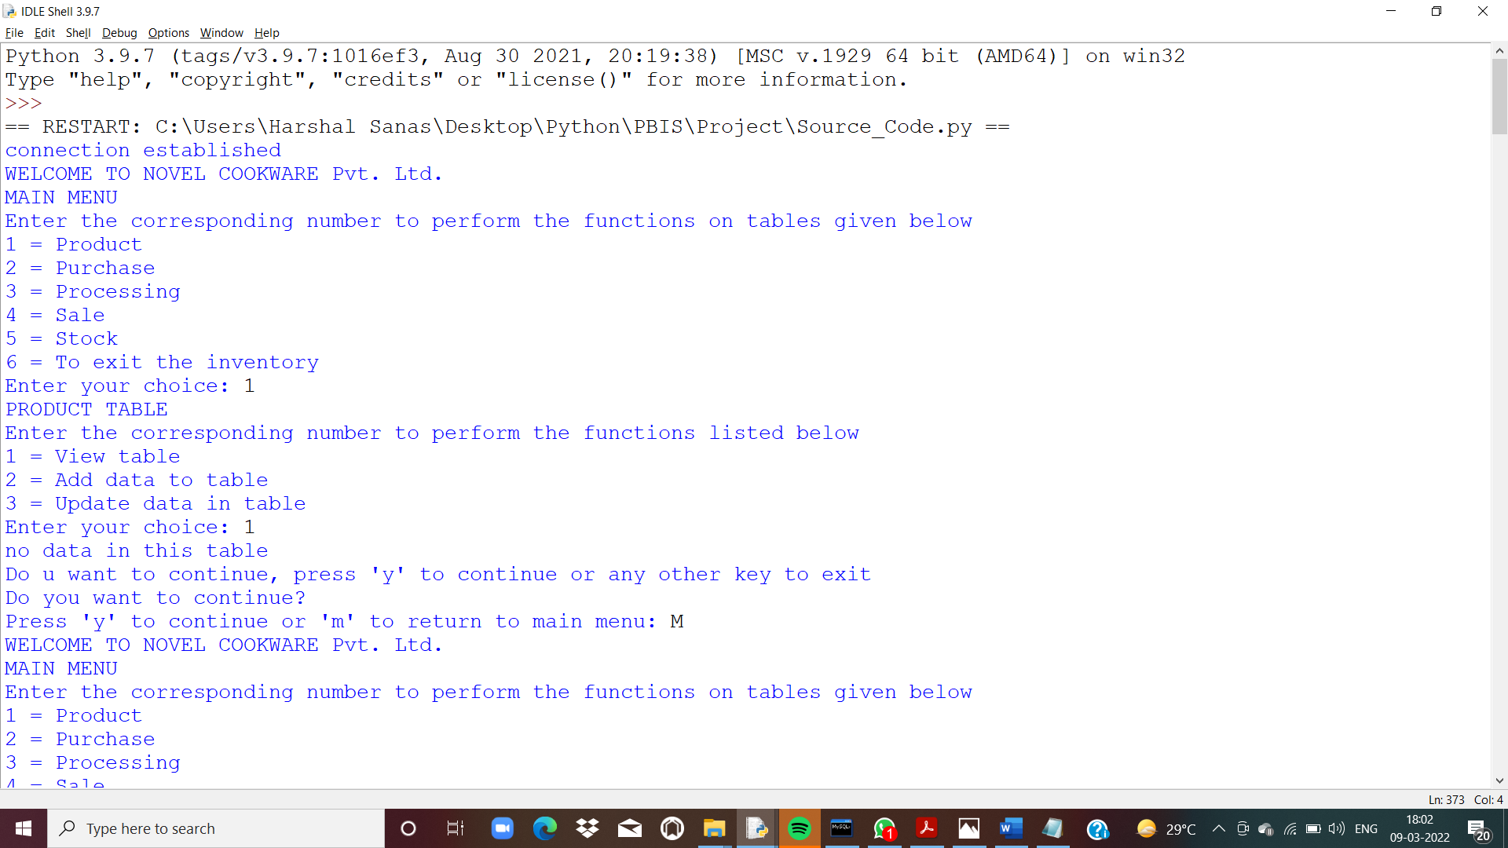

2.Product Menu

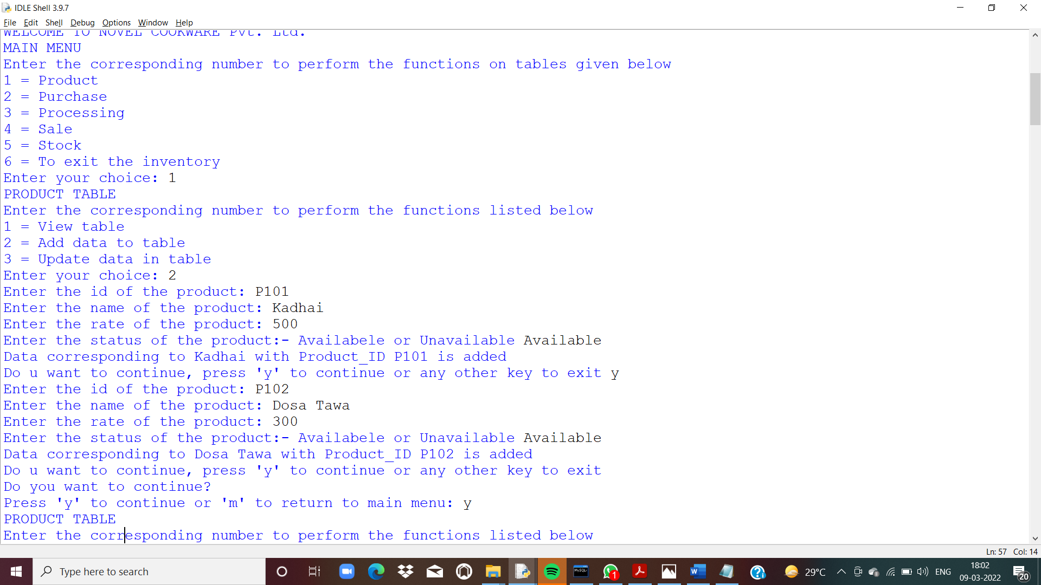

3. Adding data to Product Table



4.Updating data to Product Table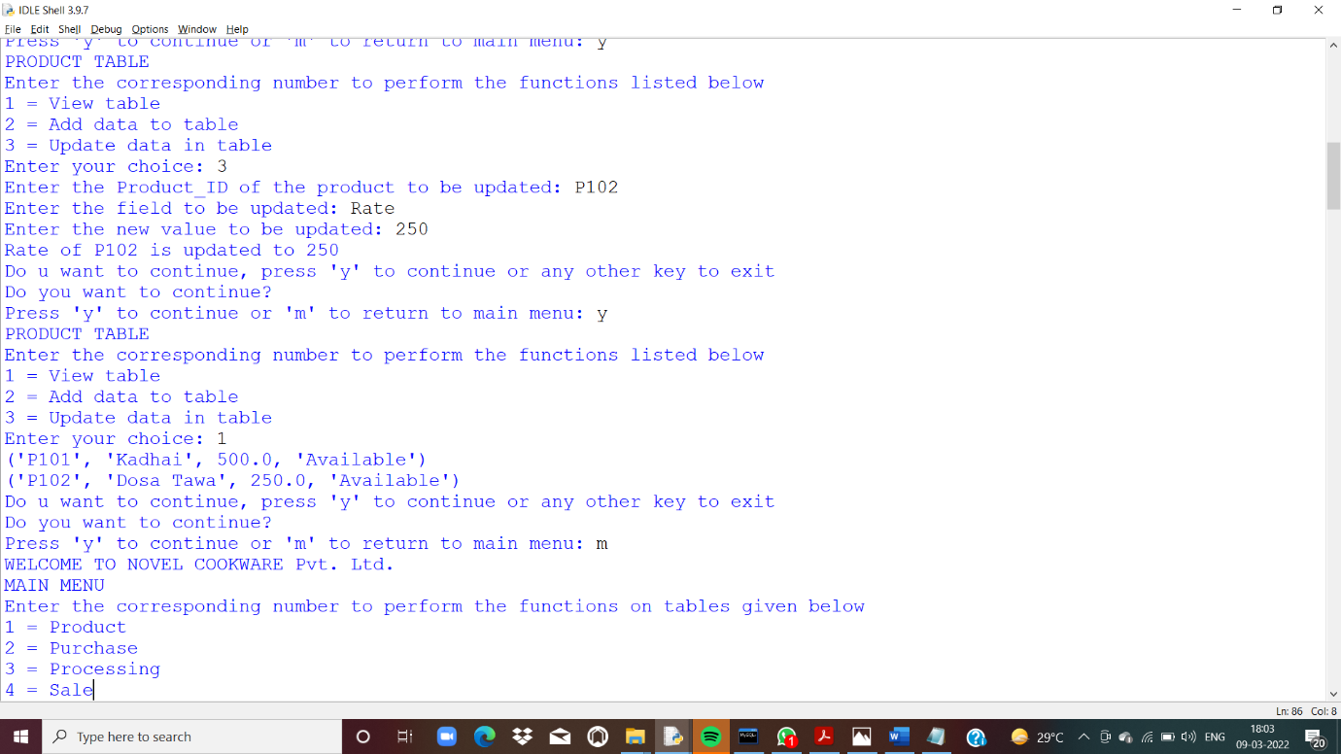

5.Viewing data to Product Table

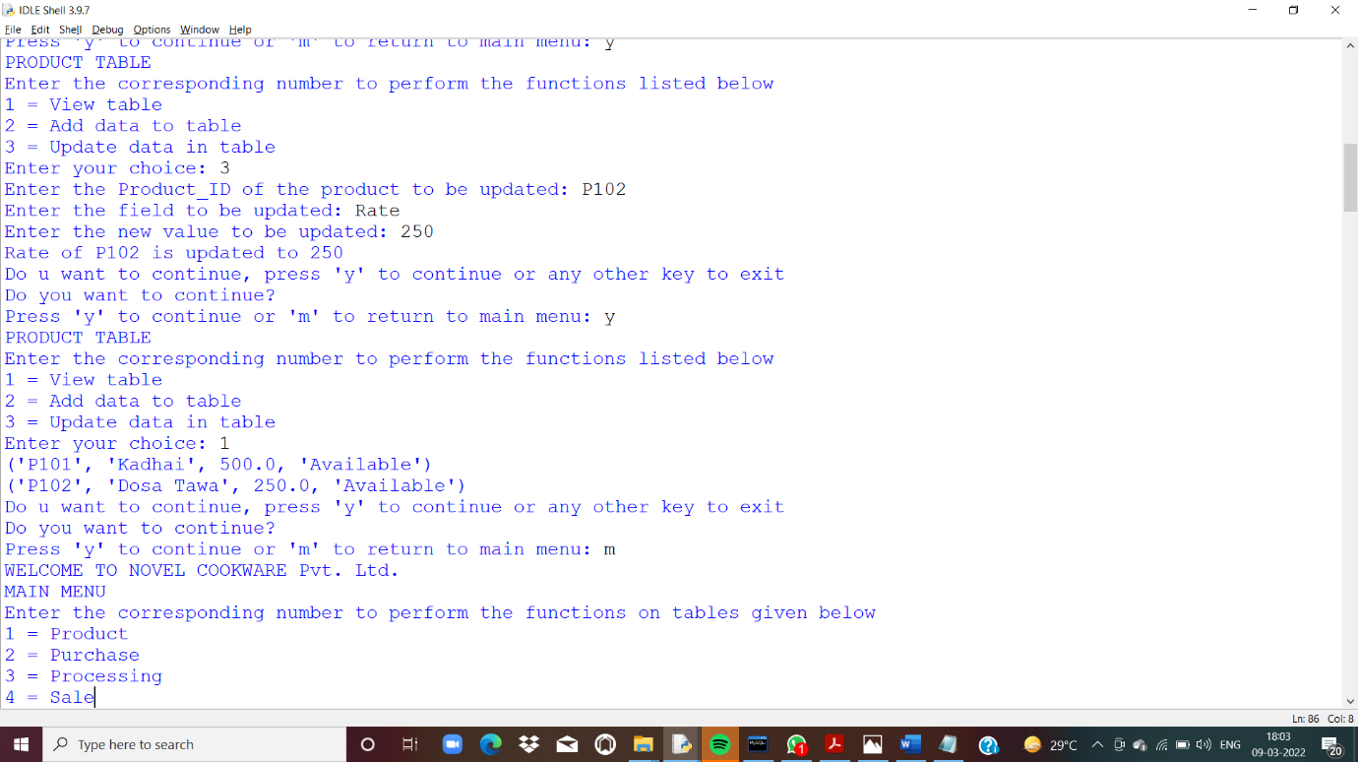

6. Purchase Menu

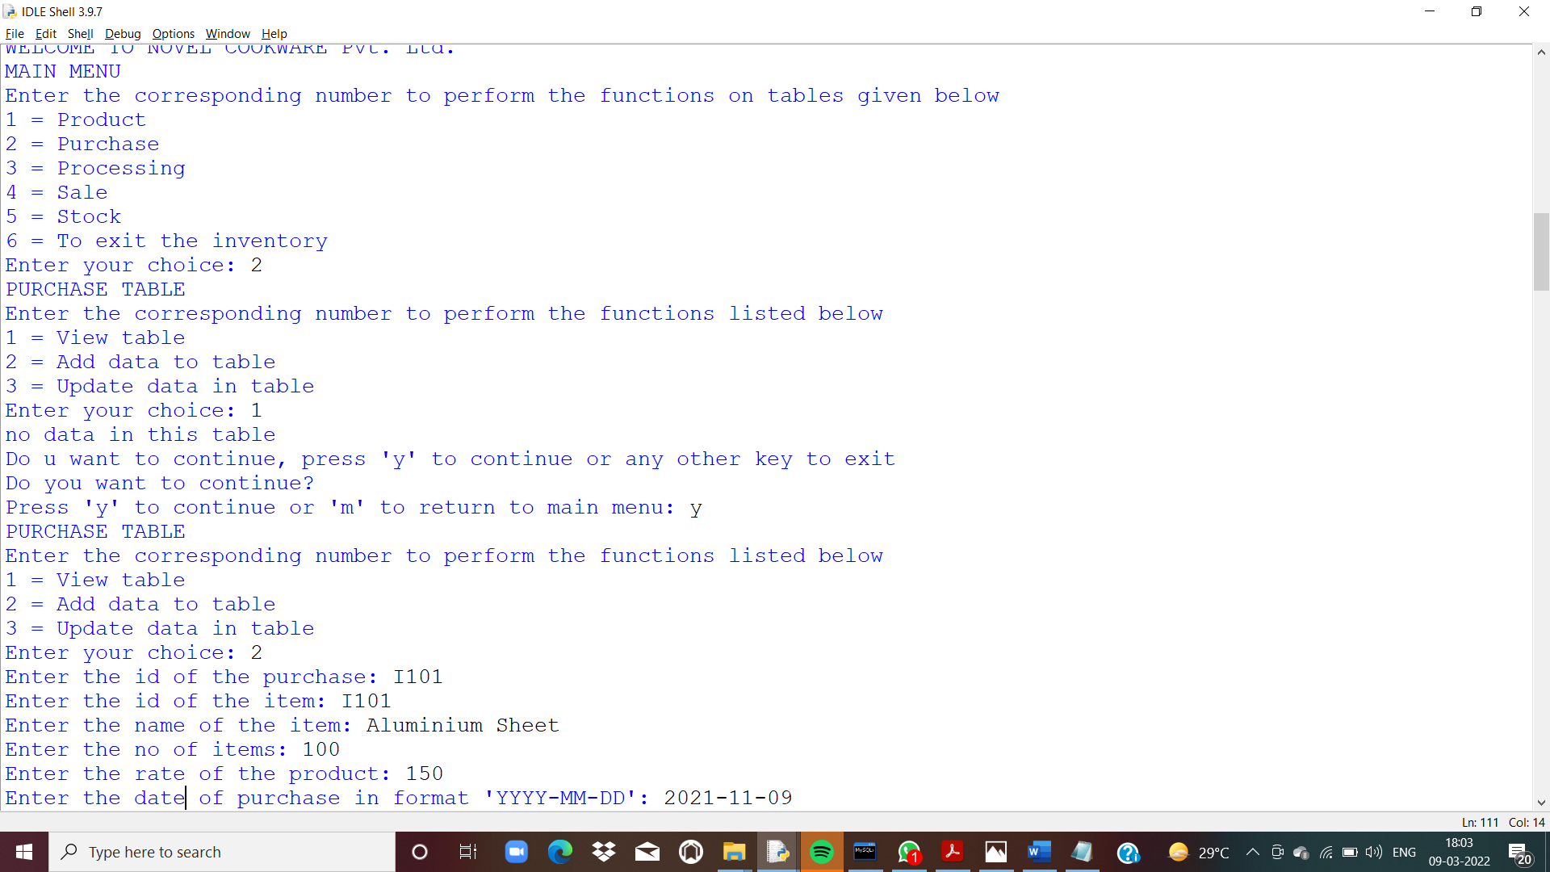

7. Adding data to Purchase Table

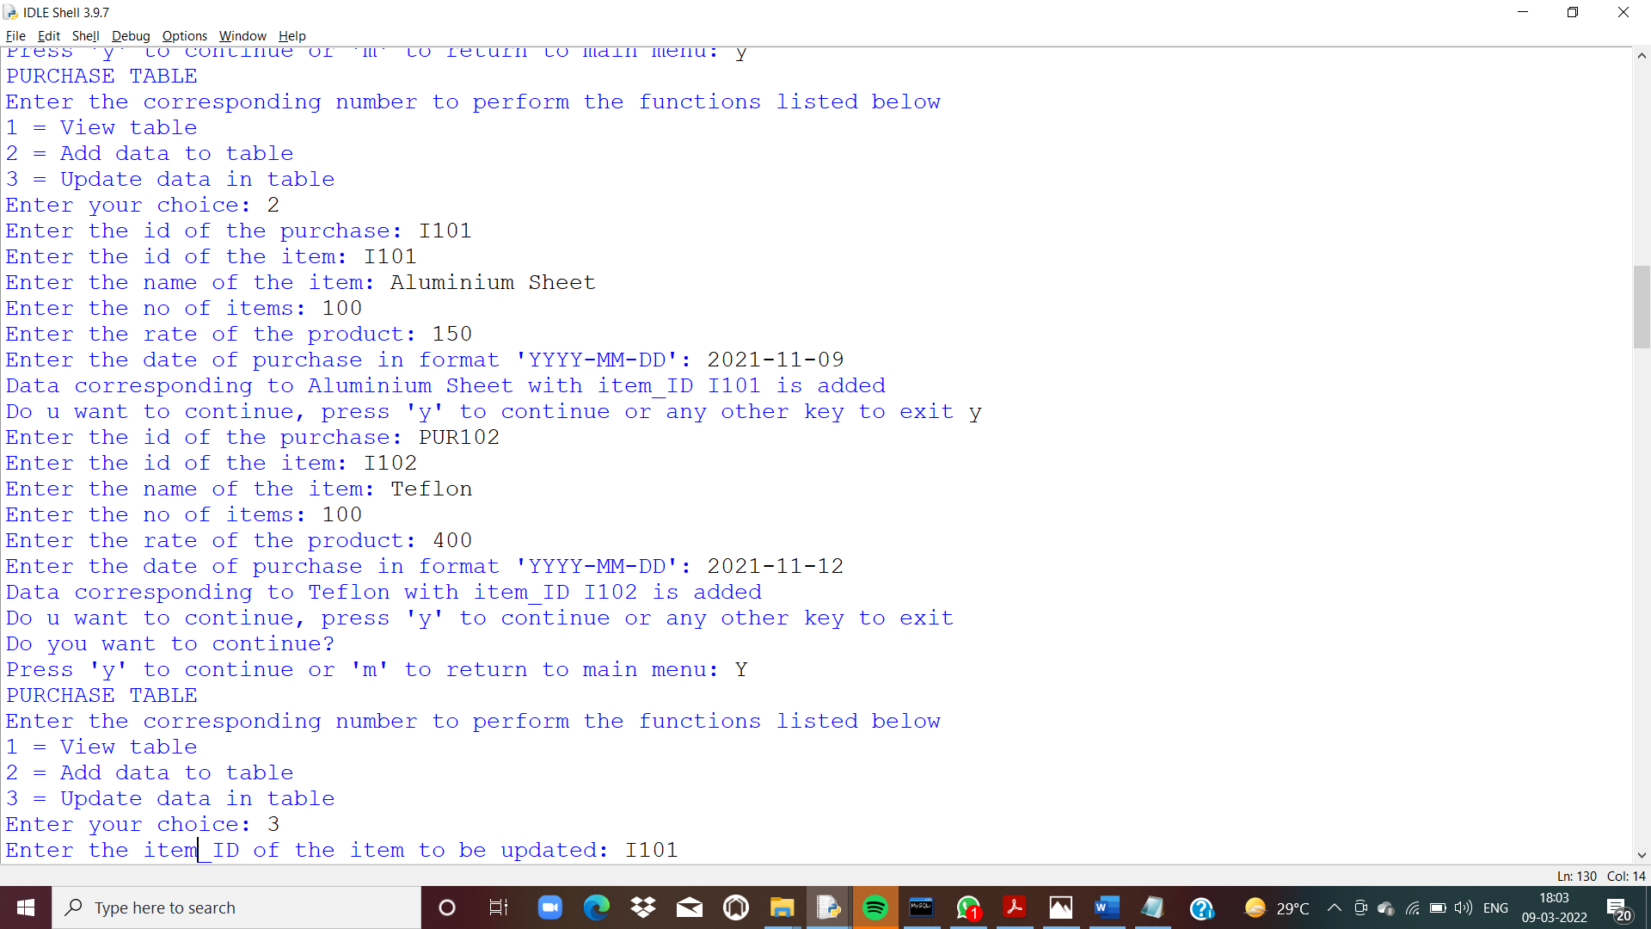

8.Updating data to Purchase Table

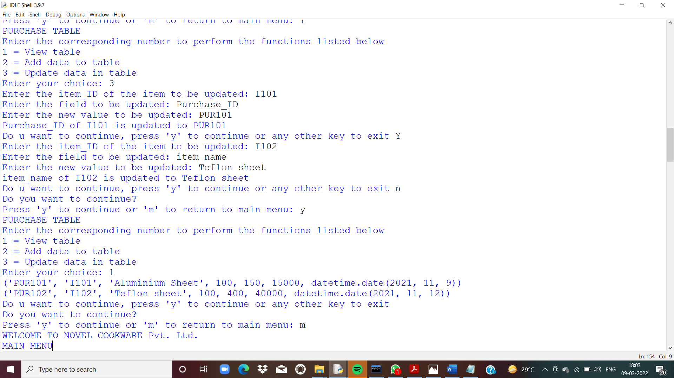

9.Viewing data to Purchase Table



10.Viewing updated stock table after entering data in

Purchase Table

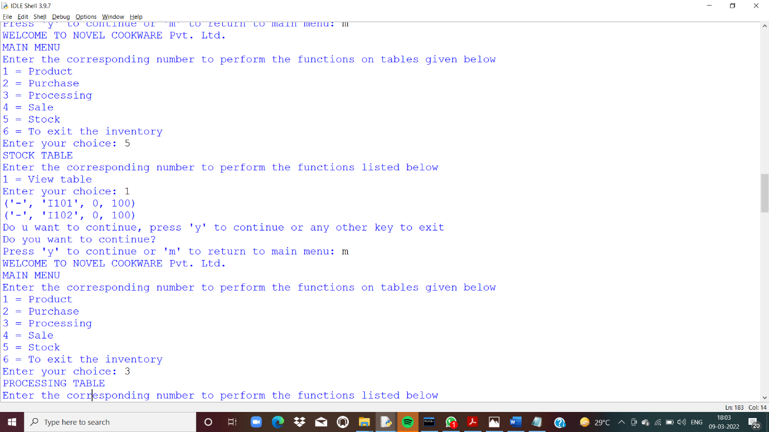

11.Processing Menu

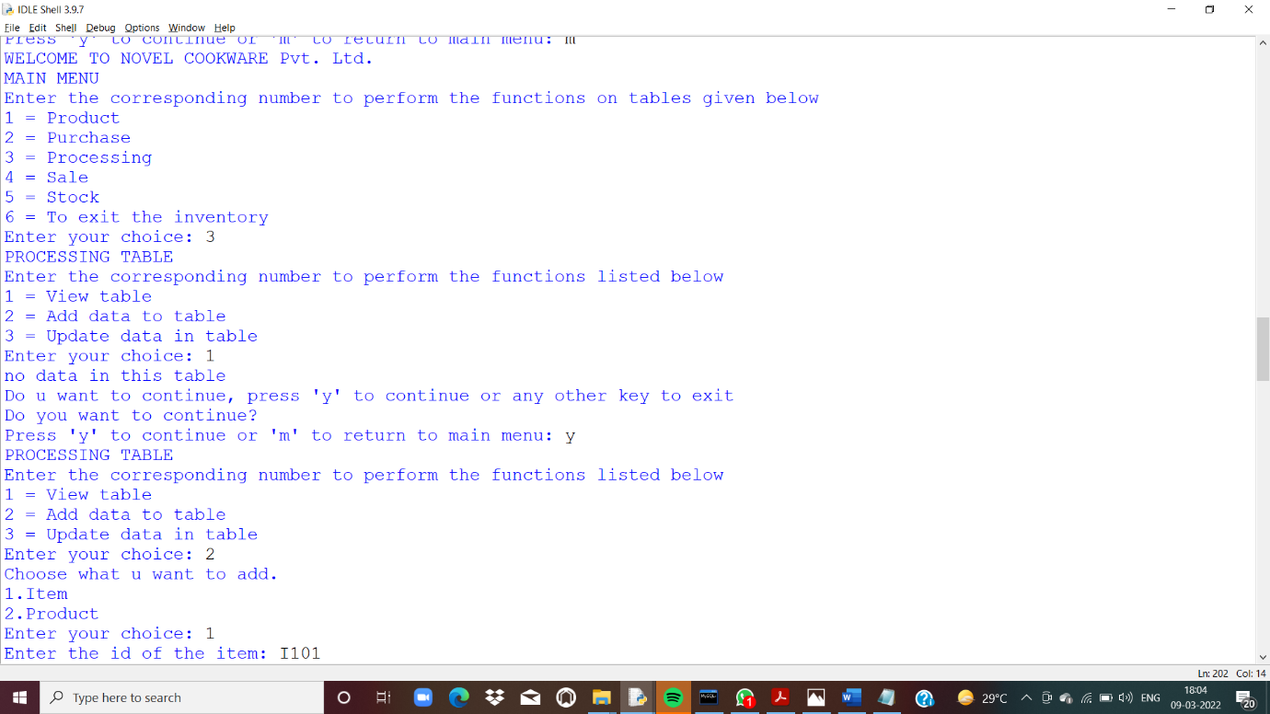

12. Adding data to Processing Table

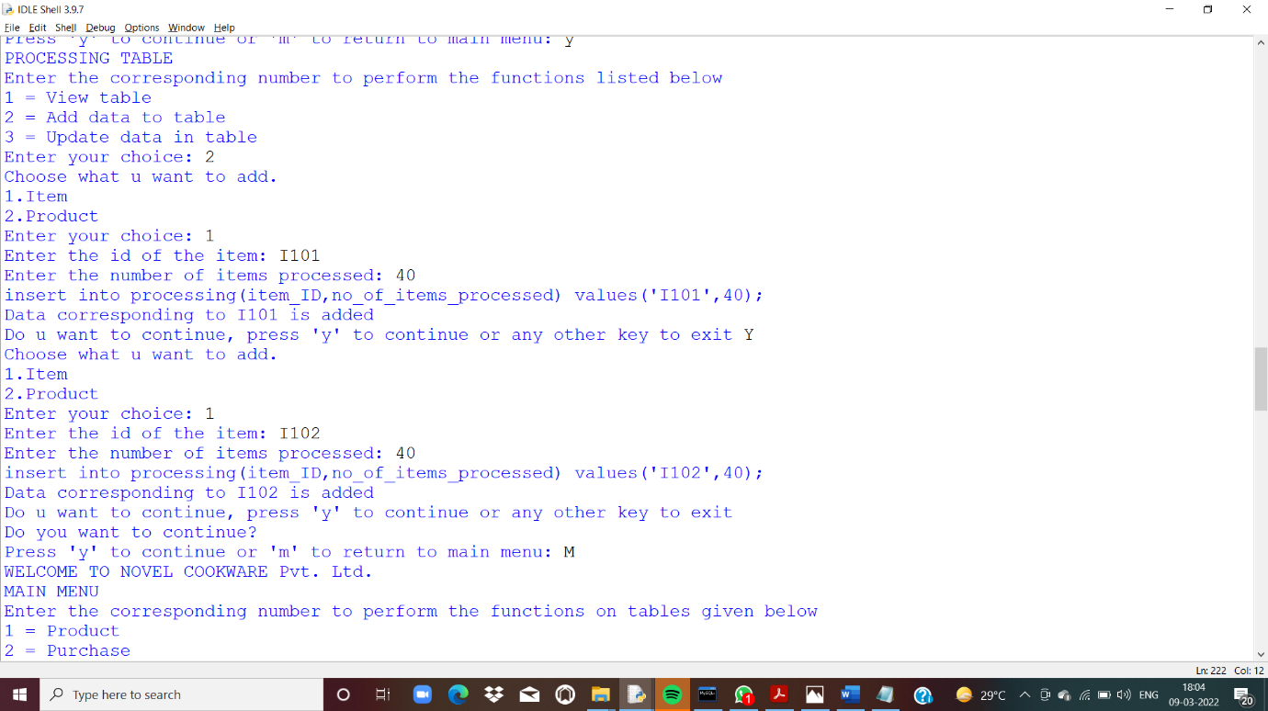

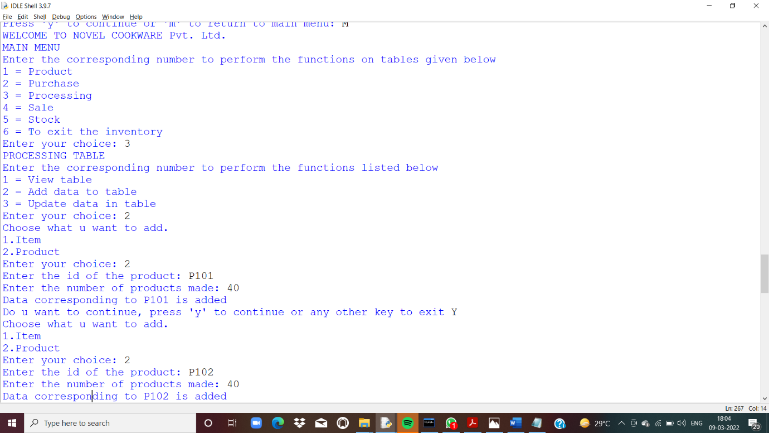

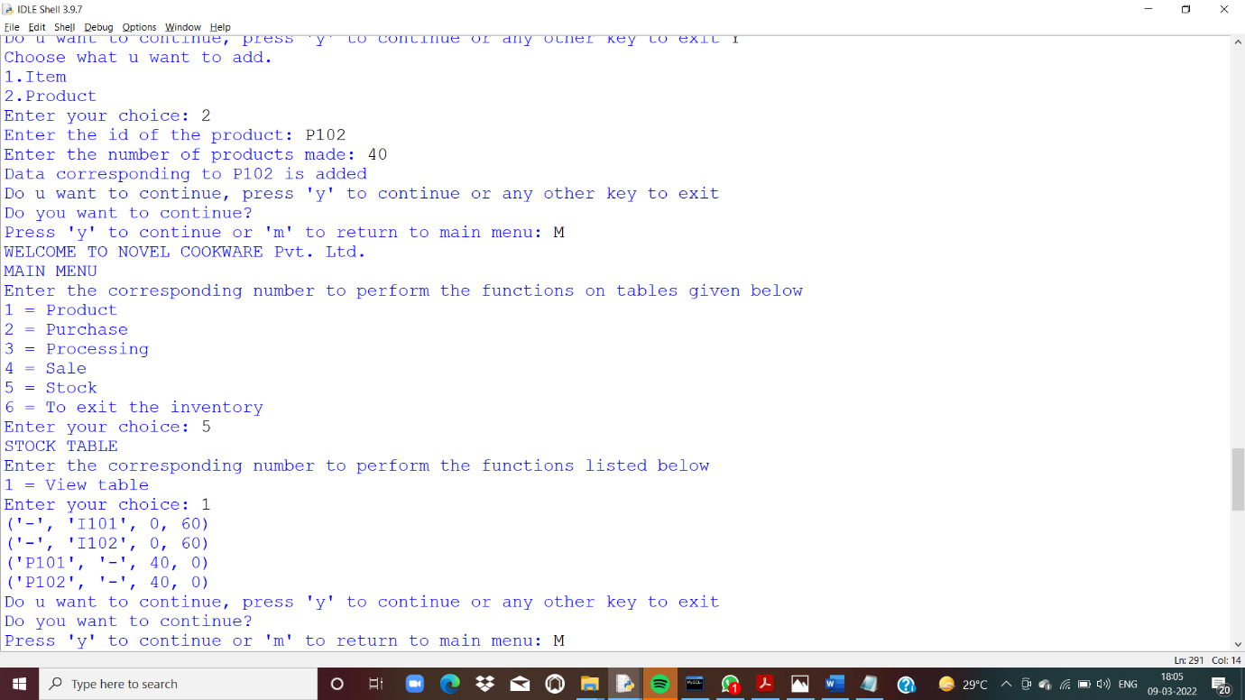

13. Viewing updated stock table after entering data in

Processing Table

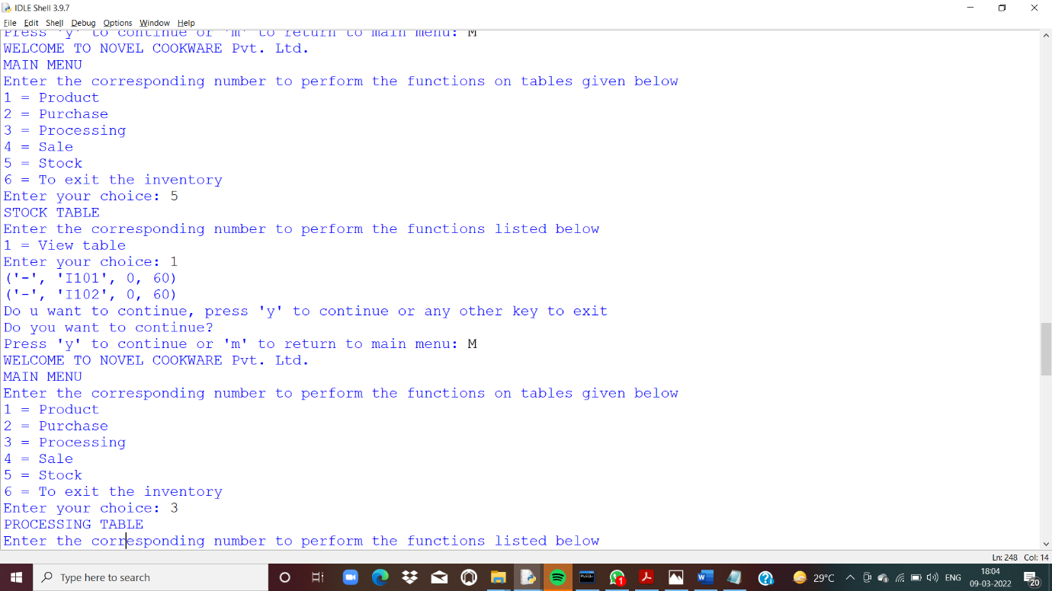



14. Viewing data to Processing Table

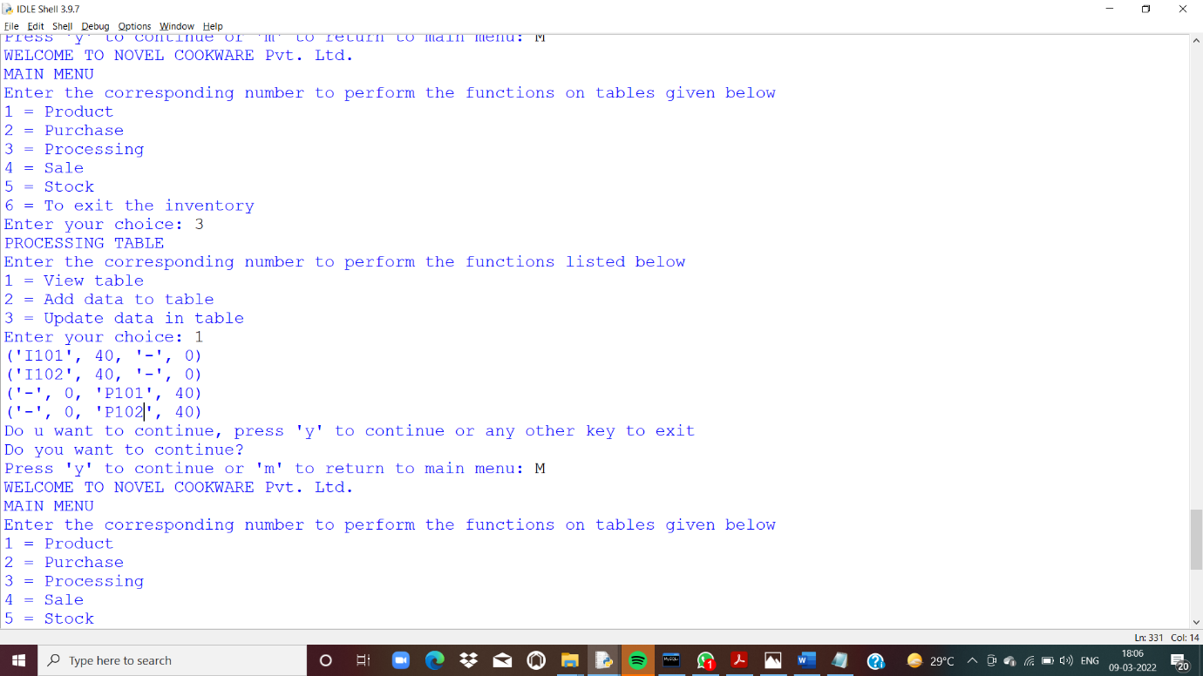

15. Sale Menu

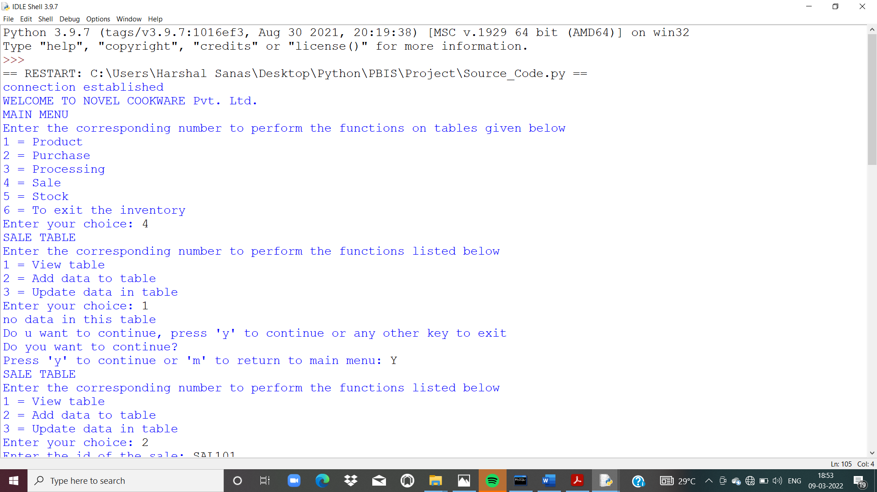

16. Adding data to Sale Table

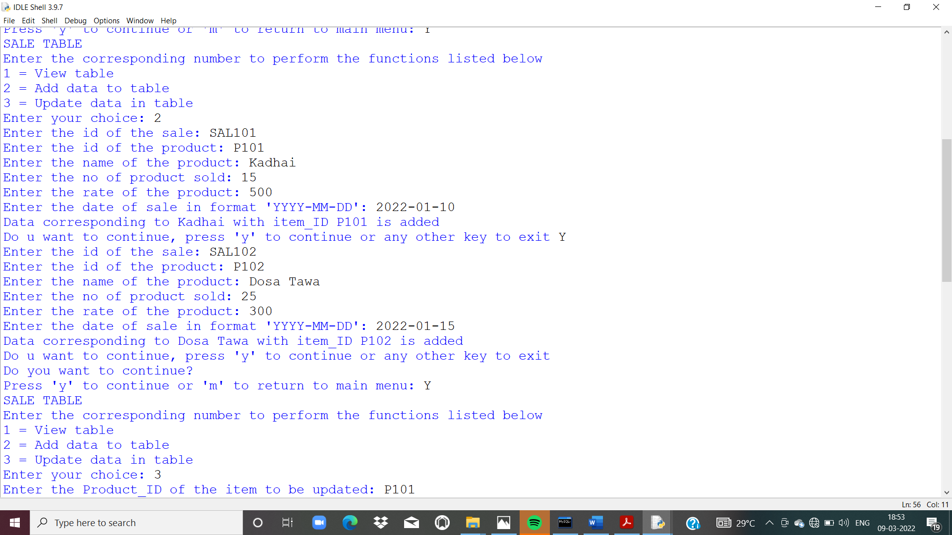

17.Viewing Sale Table

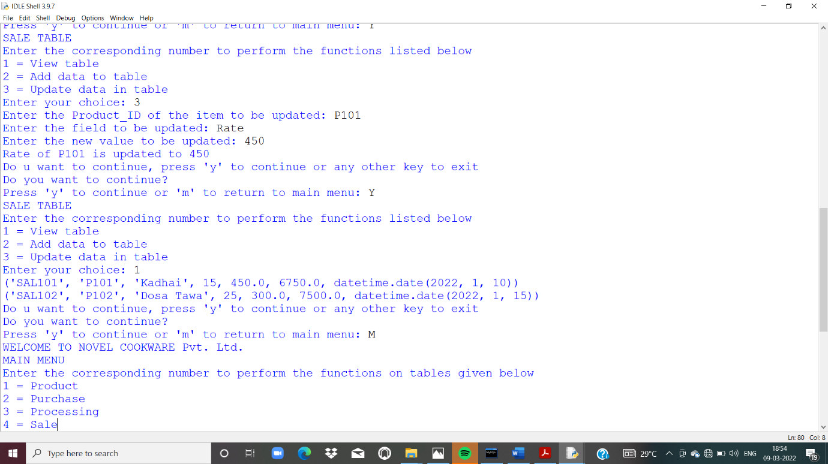

18. Viewing updated stock table after entering data in

Sale Table

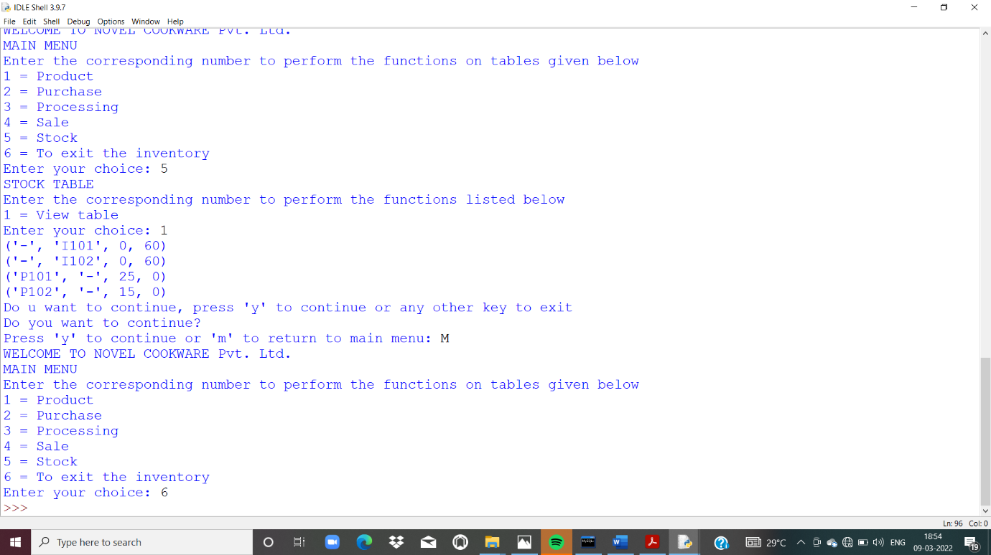

19. Terminating out of Program

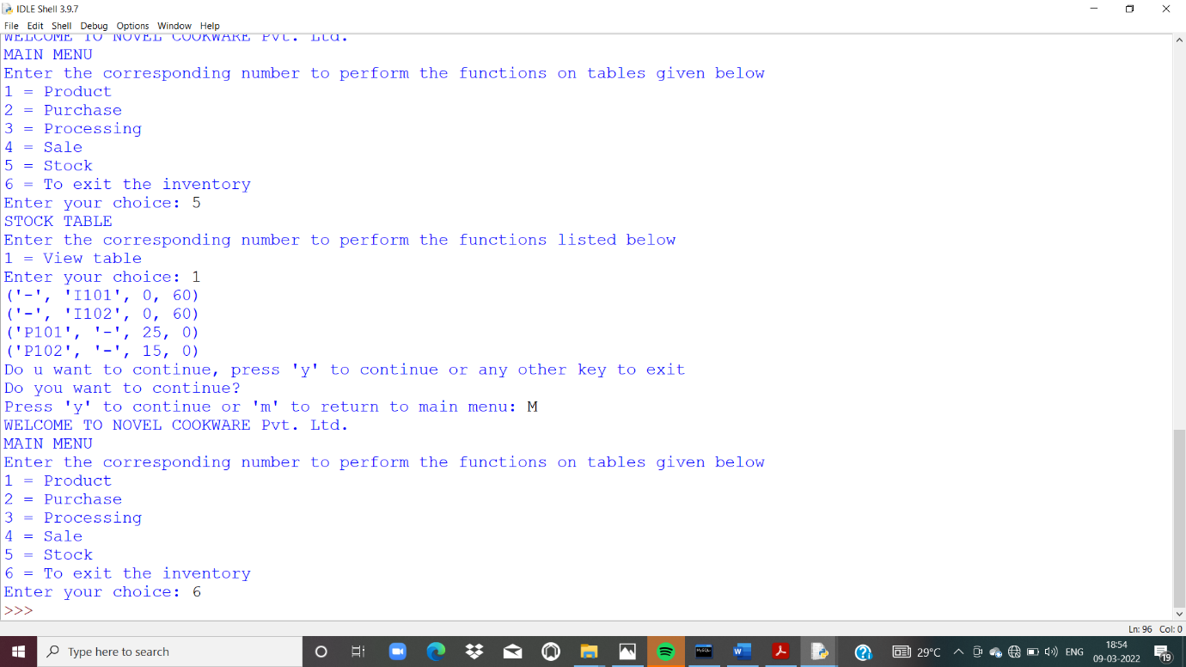

**Future Enhancements**

1. For this program completely compatible for any manufacturing company, few fields and tables wrt requirements of company can be added.
2. From accounting purposes, this program can comprise of valuation-based fields and tables.

**Bibliography**

* Introduction to python (class: XII), Sumit Arora
* NCERT (class: XI)
* NCERT (class: XII)
* <https://www.nibusinessinfo.co.uk/content/business-benefits-new-computer-hardware>
* https://smallbusiness.chron.com/disadvantages-computers-workforce-10004.html

Thank You!